PRACTICAL-9 GRAPH
Aim:- BFS and DFS in Graph
Theory:-
This program implements a graph using linked lists where each node (vertex) is connected to its edges (adjacent vertices). It defines two structures: Node, which stores a vertex and a pointer to the next node and its edge list, and Edge, which stores the destination vertex and pointer to the next edge. The createNode() function dynamically creates vertices and links them in a linked list. The createEdge() function locates the source vertex and links its destination vertices in an adjacency list using edge nodes. The printGraph() function displays the graph in adjacency list form by traversing nodes and their corresponding edges. BFS (Breadth-First Search) uses a queue and a visited array to traverse nodes level by level from the given start point. DFS (Depth-First Search) uses recursion to explore as far as possible along each branch before backtracking. In main(), user input is taken for nodes and edges, the graph is built, printed, and then both BFS and DFS traversals are executed starting from the chosen node.
Code:-
#include<stdio.h>
#include<stdlib.h>
struct Edge
{
int data;
struct Edge *edge;
};
struct Node
{
int data;
struct Node *node;
struct Edge *edge;
};
struct Node *createNode(struct Node *graph,int data)
{
struct Node *new_node=(struct Node *)malloc(sizeof(struct Node));
new_node->data=data;
new_node->node=NULL;
new_node->edge=NULL;
struct Node *ptr=graph;
if (graph==NULL)
{
printf("Node %d entered\n",data);
return new_node;
}
else
{
while (ptr->node!=NULL)
ptr=ptr->node;
ptr->node=new_node;
printf("Node %d entered\n",data);
}
}
void createEdge(struct Node *graph,int source_data,int destination_data)
{
struct Edge *new_edge=(struct Edge *)malloc(sizeof(struct Edge));
new_edge->data=destination_data;
new_edge->edge=NULL;
struct Node *ptr=graph;
while (ptr->data!=source_data)
ptr=ptr->node;
if (ptr->edge==NULL)
ptr->edge=new_edge;
else
{
struct Edge *ptr2=ptr->edge;
while (ptr2->edge!=NULL)
ptr2=ptr2->edge;
ptr2->edge=new_edge;
}
}
void printGraph(struct Node *ptr)
{
printf("Node Edge\n");
printf("List List\n");
while (ptr!=NULL)
{
printf("%d",ptr->data);
if (ptr->edge!=NULL)
{
struct Edge *ptr2=ptr->edge;
while (ptr2!=NULL)
{
printf("--->%d",ptr2->data);
ptr2=ptr2->edge;
}
}
printf("--->NULL\n");
ptr=ptr->node;
}
}
void BFS(struct Node *graph, int start)
{
int visited[100]={0};
int queue[100];
int front=0,rear=0;
queue[rear++]=start;
visited[start]=1;
printf("\nBFS Traversal starting from %d: ", start);
while (front<rear)
{
int current=queue[front++];
printf("%d ", current);
struct Node *ptr=graph;
while (ptr!=NULL && ptr->data!=current)
ptr=ptr->node;
struct Edge *e=ptr->edge;
while (e!=NULL)
{
if (!visited[e->data])
{
visited[e->data] = 1;
queue[rear++] = e->data;
}
e=e->edge;
}
}
printf("\n");
}
void DFSUtil(struct Node *graph, int data, int visited[])
{
visited[data] = 1;
printf("%d ", data);
struct Node *ptr = graph;
while (ptr != NULL && ptr->data != data)
ptr = ptr->node;
struct Edge *e = ptr->edge;
while (e != NULL)
{
if (!visited[e->data])
DFSUtil(graph, e->data, visited);
e = e->edge;
}
}
void DFS(struct Node *graph, int start)
{
int visited[100] = {0};
printf("\nDFS Traversal starting from %d: ", start);
DFSUtil(graph, start, visited);
printf("\n");
}
int main()
{
int n,e,sd,dd;
int vertex[10];
struct Node *graph=NULL;
printf("Enter no. of Nodes:-");
scanf("%d",&n);
for (int i=0;i<n;i++)
{
printf("Enter name of node %d:-",i+1);
scanf("%d",&vertex[i]);
if (i==0)
graph=createNode(graph,vertex[i]);
else
createNode(graph,vertex[i]);
}
printf("\nEnter no of edges:-");
scanf("%d",&e);
for (int i=0;i<e;i++)
{
printf("Enter source and destination for %d edge:-",i+1);
scanf("%d %d",&sd,&dd);
createEdge(graph,sd,dd);
}
printGraph(graph);
int start;
printf("\nEnter starting node for BFS & DFS: ");
scanf("%d", &start);
DFS(graph, start);
BFS(graph, start);
return 0;
}
Output:-
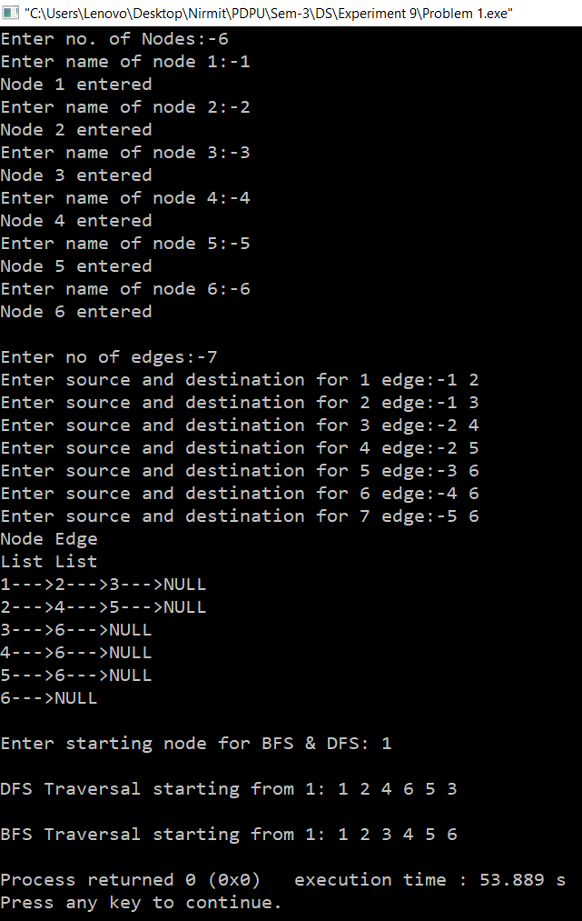
Time complexity:- O(V+E) where V is the node and E is the edge
Space complexity:- O(V+E)

